Wanake
Summer Camp 2026


Wanake Summer Camp 2026
Wanake Adventures 2026
A Week-Long Summer Camp Experience
For Grades 1-12 in the fall of 2026

Wanake Adventures is the classic “build-your-own-adventure” style camp!
Each group helps plan elements of their week, creating a unique and exciting camping experience.
Activities for all groups include swimming, building campfires, Bible study, arts & crafts, games, worship, hiking, ice cream breakfast, cookouts, singing, 9-Square, and GaGa Ball. Campers also have the option to visit the Wanake Farm, take a polar bear swim, or hit the waterslide.

Grades 1–3: Follow a pre-planned schedule that includes traditional camp activities like visiting the Frog Pond and making homemade ice cream.

Grades 4–6: Follow a partially pre-planned schedule with all the activities above, plus a choice of rock climbing or canoeing.

Grades 6–8: Choose one or two additional activities from the Jr. High Adventure list, including Rock Climbing, Star Gazing/Telescope, Night Hike, Canoeing, and the Challenge Course.

Grades 9–12: Select a few activities from the Sr. High Adventure list, including Canoeing, Challenge Course, Rock Climbing, Canoe Swamping, or a Service Project. – Want more of a challenge? Check out Wanake Adventures Advanced (Page 3) or Rock Lodge Quest (Page 4)!
At every age, campers are challenged to grow and develop age-appropriate skills, including:
- decision making,
- friendship building,
- outdoor living,
- taking responsibility for themselves,
- leadership,
- living as disciples of Christ, and more.

As campers become tweens, teens and young adults, they are progressively challenged to develop their skills further, have opportunities to try more challenging activities, and take more leadership of their group for an even more rewarding week!
Housing is in Retreat Centers or Cabins with a sleepout under the stars for grades 4-6, or an overnight in the Survival Cabin, Adirondacks, or Rock Lodge for grades 6-12. If your camper requires a specific housing option, please contact Wanake to arrange for their housing.
June 14-19
June 21-26
June 28-July 3 - $50 Discount Before March 15 | $25 Discount After March 15 & Before April 30
July 5-10
July 12-17
July 26-31

$575 – Tier 1 - $550 Early Bird (register by April 15); $525 SUPER Early Bird (register by March 15)
$647 – Tier 2 - $622 Early Bird (register by April 15); $597 SUPER Early Bird (register by March 15)
$762 – Tier 3 - $737 Early Bird (register by April 15); $712 SUPER Early Bird (register by March 15)

Wanake Adventures Advanced
Grades 9-12 in the Fall of 2026
Wanake Adventures Advanced is perfect for campers who love the “build-your-own-adventure” style but are ready for more of a challenge! Spend the week choosing from the on-site Sr. High Advanced Adventure list, which includes Building a Raft, Canoeing, Bouldering, Rock Climbing, Swamp-a-Canoe, and an Outer-Woods Hike, as well as a choice of a Waterfall Hike, a day at nearby Baylor Beach, or a trip down the Tuscarawas River.
Build teamwork and critical thinking skills at the Wanake Challenge Course, and enjoy familiar favorites like GaGa Ball, 9-Square, Bible Study, cookouts, worship, and swimming.
Campers live in Cabins or a Retreat Center, with an overnight in one of Wanake’s Rustic Locations. If your camper requires a specific housing option, please contact Wanake to arrange accommodations.

June 14-19
June 21-26
June 28-July 3 - $50 Discount Before March 15 | $25 Discount After March 15 & Before April 30
July 12-17
July 26-31

$605 – Tier 1 - $580 Early Bird (register by April 15); $555 SUPER Early Bird (register by March 15)
$677 – Tier 2 - $652 Early Bird (register by April 15); $627 SUPER Early Bird (register by March 15)
$792 – Tier 3 - $767 Early Bird (register by April 15); $742 SUPER Early Bird (register by March 15)

Week-Long Themed Programs
at Wanake Summer 2026

Rock Lodge Quest
Grades 9-12 in the Fall of 2026
Ready for the ultimate Wanake experience? Live in the Rock Lodge and experience a week packed with challenges, adventure, and fun! Cookout one or two meals a day, practice your canoeing skills on Wanake’s Lake Arnold, and climb the rock wall at the Outpost Barn. Explore the outer woods of Wanake, go swimming, and enjoy favorites like 9-Square and GaGa Ball. Spend time unwinding in hammocks, diving into the Bible, and worshiping together. Have an EPIC adventure and enjoy the Rock Lodge with friends, old and new! Live in the Rock Lodge.
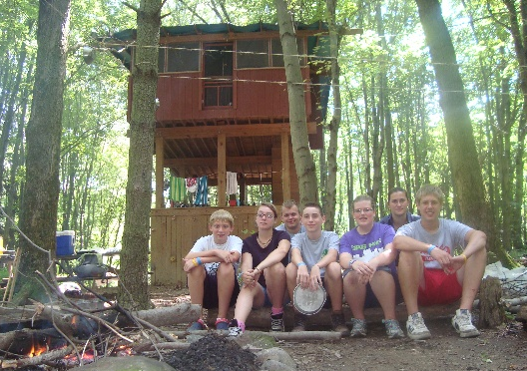
July 5-10

$585 – Tier 1 - $560 Early Bird (register by April 15); $535 SUPER Early Bird (register by March 15)
$657 – Tier 2 - $632 Early Bird (register by April 15); $607 SUPER Early Bird (register by March 15)
$772 – Tier 3 - $747 Early Bird (register by April 15); $722 SUPER Early Bird (register by March 15)

Summer Games!
Grades 5-7 in the Fall of 2026
Love playing games and staying active? This camp is made for you! Spend the week trying all kinds of sports and games. From soccer, basketball, kickball, wiffleball, volleyball, and swimming to Gold Rush, 9-Square, and GaGa Ball. Learn new skills, make friends, and enjoy the thrill of friendly competition in a safe and supportive environment.
Of course, it’s still classic Wanake camp too! Campers will swim, craft, worship, cook out, enjoy campfires, and dive into Bible study. Each day is a mix of action, adventure, and the favorite activities that make camp unforgettable.
Live in Cabins or a Retreat Center, with an overnight in one of Wanake’s rustic locations! If your camper requires a specific housing option, please contact Wanake to arrange accommodations.

July 12-17

$580 – Tier 1 - $555 Early Bird (register by April 15); $530 SUPER Early Bird (register by March 15)

$652 – Tier 2 - $627 Early Bird (register by April 15); $602 SUPER Early Bird (register by March 15)
$767 – Tier 3 - $742 Early Bird (register by April 15); $717 SUPER Early Bird (register by March 15)
Animal Friends
Grades 3-5 in the Fall of 2026
Spend time at the Wanake Farm with goats, rabbits, cats, and other guest animals! Help take care of the farm animals by feeding, watering, and exercising them. Explore the animals living in the Frog Pond, Lake Arnold, and the woods—home to Wanake’s incredible bullfrogs and turtles! Keep
your eyes open for native wildlife like birds, squirrels, butterflies, fish, and deer.
Enjoy swimming, crafting, Bible exploration, cookouts, games, s’mores, and even an ice cream breakfast! Live in Cabins or a Retreat Center, with a sleep out under the stars. If your camper requires a specific housing option, please contact Wanake to arrange accommodations.

June 14-19
June 28-July 3
July 12-17

$580 – Tier 1 - $555 Early Bird (register by April 15); $530 SUPER Early Bird (register by March 15)
$652 – Tier 2 - $627 Early Bird (register by April 15); $602 SUPER Early Bird (register by March 15)
$767 – Tier 3 - $742 Early Bird (register by April 15); $717 SUPER Early Bird (register by March 15)

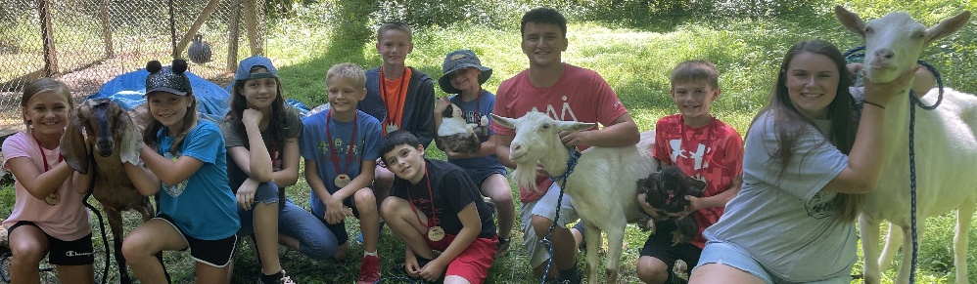

Tails & Trails

Grades 6-8 in the Fall of 2026
Spend your week with the goats, rabbits, cats, and other guest animals at the Wanake Farm! Help take care of the animals by feeding, watering, and exercising them, and discover the wild animals that call Wanake home—like hummingbirds, chipmunks, deer, frogs, and groundhogs.
When you’re not at the farm, dive into all kinds of camp adventures! Swimming, crafting, explore the Bible, play games, go canoeing, cook out, and enjoy favorites like s’mores and the ice cream breakfast. Live in Cabins or a Retreat Center and spend a night in one of Wanake’s rustic locations. If your camper requires a specific housing option, please contact Wanake to arrange accommodations.

June 21-26
July 5-10

$580 – Tier 1 - $555 Early Bird (register by April 15); $530 SUPER Early Bird (register by March 15)
$652 – Tier 2 - $627 Early Bird (register by April 15); $602 SUPER Early Bird (register by March 15)
$767 – Tier 3 - $742 Early Bird (register by April 15); $717 SUPER Early Bird (register by March 15)

Moonlight Madness
Grades 7-9 in the Fall of 2026
Jump moon shadows and experience the magic of camp by the light of the moon! Stay up late—until 3 AM—and sleep in until noon. Spend your days swimming, canoeing, and relaxing, then come alive at night with campfires, Bible study, night hikes, worship, rock climbing, stargazing, and glowing night games.
You’ll flip your schedule—eat breakfast at lunch, lunch at dinner, and dinner under the stars! Peer through a telescope to see the moon, planets, and nebulae up close. It’s a week full of moonlight, laughter, and late-night adventure! Live in Cabins.
If your camper requires a specific housing option, please contact Wanake to arrange accommodations.

June 28-July 3

$580 – Tier 1 - $555 Early Bird (register by April 15); $530 SUPER Early Bird (register by March 15)
$652 – Tier 2 - $627 Early Bird (register by April 15); $602 SUPER Early Bird (register by March 15)
$767 – Tier 3 - $742 Early Bird (register by April 15); $717 SUPER Early Bird (register by March 15)
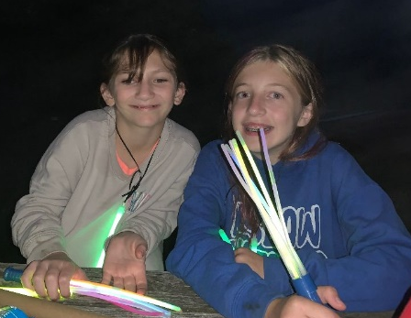

Night Games
Grades 7-9 in the Fall of 2026

Defy the clock! Stay up until 3 AM and sleep until noon! Canoe and swim before it gets dark. After dark, rock climb, stargaze, night hike, craft, explore the Bible, and star gaze. See the stars, planets and nebulae up close through a telescope. Try glow-in-the-dark games and activities that light up the night! Eat breakfast at lunch, lunch at dinner, and dinner when the stars are in the sky. Play your favorite camp games and learn new ones, all with night-time twists! Live in a Retreat Center. If your camper requires a specific housing option, please contact Wanake to arrange for their housing.

July 12-17

$580 – Tier 1 - $555 Early Bird (register by April 15); $530 SUPER Early Bird (register by March 15)
$652 – Tier 2 - $627 Early Bird (register by April 15); $602 SUPER Early Bird (register by March 15)
$767 – Tier 3 - $742 Early Bird (register by April 15); $717 SUPER Early Bird (register by March 15)



Pool Pizzazz
Grades 3-5 in the Fall of 2026
Hot summer days are just ahead—beat the heat at the Wanake Pool! Splash, play, and cool off with extra pool time, pool games, basketball, and more. Scale the pool climbing wall, leap off the diving board, and race down the water slide!
Head to Lake Arnold for even more adventure with canoeing and rock climbing. Enjoy cookouts, camp games, and evening campfires. Savor the flavor of s’mores, Wanake’s famous Ice Cream Breakfast, and God’s sweet Word—the Bible.
Live in Cabins or a Retreat Center and spend a night under the stars. If your camper requires a specific housing option, please contact Wanake to arrange accommodations.
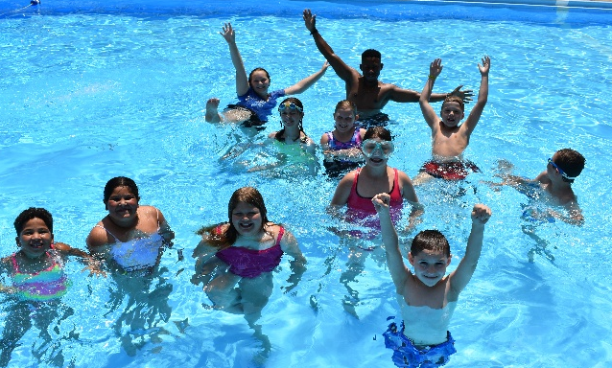
June 21-26
July 5-10
July 26-31

$575 – Tier 1 - $550 Early Bird (register by April 15); $525 SUPER Early Bird (register by March 15)
$647 – Tier 2 - $622 Early Bird (register by April 15); $597 SUPER Early Bird (register by March 15)
$762 – Tier 3 - $737 Early Bird (register by April 15); $712 SUPER Early Bird (register by March 15)

Pool Daze
Grades 6-8 in the Fall of 2026
Beat the heat at the Wanake Pool! Enjoy extra swim times, pool basketball, and all your favorite ways to make a splash. Scale the pool climbing wall, leap off the diving board, and fly down the waterslide!

Head to Lake Arnold for canoeing adventures, then spend time crafting, cooking out, playing games, and gathering around the campfire. Take a trip to nearby Baylor Beach for swimming, water slides, and a barrel roll in the sun!
Live in Cabins or a Retreat Center and spend a night in one of Wanake’s three rustic locations. If your camper requires a specific housing option, please contact Wanake to arrange accommodations.

June 14-19
July 12-17
July 26-31

$600 – Tier 1 - $575 Early Bird (register by April 15); $550 SUPER Early Bird (register by March 15)
$672 – Tier 2 - $647 Early Bird (register by April 15); $622 SUPER Early Bird (register by March 15)
$787 – Tier 3 - $762 Early Bird (register by April 15); $737 SUPER Early Bird (register by March 15)

Wet & Wild

Grades 9-12 in the Fall of 2026
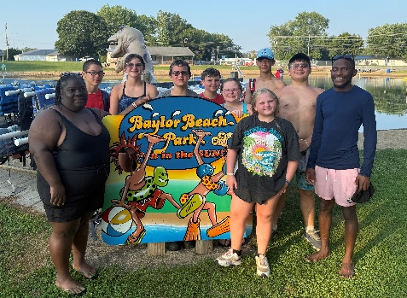
Enjoy water fun? Like to act wild? Pump up the excitement at the Wanake Pool with the climbing wall, diving board, and pool basketball action. Canoe across Wanake’s Lake Arnold, dive into Bible study, and soak up summer adventure!
Top off your week with a trip to Baylor Beach for swimming, slides, the high dive, and a barrel roll in the sun. Live in Cabins or a Retreat Center and spend a night in one of Wanake’s three rustic locations.
If your camper requires a specific housing option, please contact Wanake to arrange accommodations.

June 28-July 3

$600 – Tier 1 - $575 Early Bird (register by April 15); $550 SUPER Early Bird (register by March 15)
$672 – Tier 2 - $647 Early Bird (register by April 15); $622 SUPER Early Bird (register by March 15)
$787 – Tier 3 - $762 Early Bird (register by April 15); $737 SUPER Early Bird (register by March 15)

Fishing Camp
Grades 9-12 in the Fall of 2026
Fish daily with friends and our master fisherman, Brian Zimmerman! Travel to fish in rivers and lakes and learn about the fish species who live there. The week includes an overnight fishing trip to a nearby lake and a canoe trip down the Tuscarawas River to fish. Bring your pole and tackle box or use a Wanake pole. There will be opportunities to swim, explore the Bible, cookout, play games, and enjoy s’mores. Live in Cabins near the lake. If your camper requires a specific housing option, please contact Wanake to arrange for their housing.
July 26-31

$610 – Tier 1 - $585 Early Bird (register by April 15); $560 SUPER Early Bird (register by March 15)
$682 – Tier 2 - $657 Early Bird (register by April 15); $632 SUPER Early Bird (register by March 15)
$797 – Tier 3 - $772 Early Bird (register by April 15); $747 SUPER Early Bird (register by March 15)
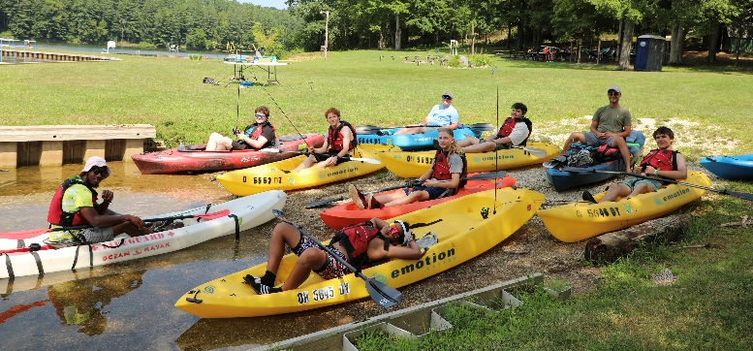



Teen Leadership Programs

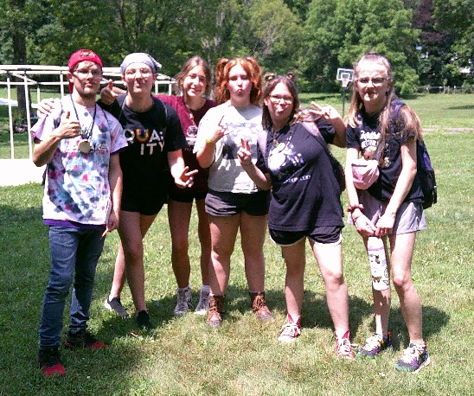
Leader in Training (LIT)
Grades 10-12 in the Fall of 2026
Are you interested in being a leader at camp? Learn skills you can apply at camp and beyond: child development, outdoor living skills, team building, and leadership basics. LIT campers have fun together as a group, take in learning sessions, and work in younger camp groups to put their new learning into action. Leaders in training may be invited back to help throughout the summer and during the year as their skills are needed. Live in a Retreat Center. If your camper requires a specific housing option, please contact Wanake to arrange for their housing.

June 14-19

$580 – Tier 1 - $555 Early Bird (register by April 15); $530 SUPER Early Bird (register by March 15)
$652 – Tier 2 - $627 Early Bird (register by April 15); $602 SUPER Early Bird (register by March 15)
$767 – Tier 3 - $742 Early Bird (register by April 15); $717 SUPER Early Bird (register by March 15)

Buddies as Leaders
Grades 10-12 in the Fall of 2026
Be a camp buddy for an adult with developmental disabilities. Enjoy all the fun of camping with your new camp friend. Swim, sing, craft, play games, cookout, and build a friendship and a bond. A dance party, wagon ride and visits to the Wanake farm will help make this week a week to remember. Live in a Retreat Center with your buddy.
This week can be used to fulfill community hours for high school graduation or a career working with individuals with disabilities.

July 12-17

$580 – Tier 1 - $555 Early Bird (register by April 15); $530 SUPER Early Bird (register by March 15)
$652 – Tier 2 - $627 Early Bird (register by April 15); $602 SUPER Early Bird (register by March 15)
$767 – Tier 3 - $742 Early Bird (register by April 15); $717 SUPER Early Bird (register by March 15)

Checkout Short Programs & Weeklong Day Camp
on the Next Page!

Short Programs and Day Camp

Discover Camp!
A 3-day, 2-night program
For grades 1-6 in the fall of 2026
Discover what Wanake has to offer: swimming, campfires, games, nature exploration, visiting the animals, eating s’mores, and meeting new friends! This is an excellent introduction to overnight camping. Live in Cabins or a Retreat Center. If your camper requires a specific housing option, please contact Wanake to arrange for their housing.
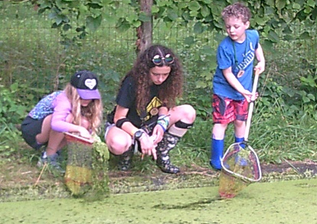
Camper check-in is 3 PM on Sundays and Wednesdays and camper pick-up includes a parent program on Tuesdays or Fridays starting at 4:30 PM.

June 14-16 – Grades 1-3 (Sunday-Tuesday)
June 17-19 – Grades 4-6 (Wednesday-Friday)
July 1-3 – Grades 1-6 (Wednesday-Friday)
July 5-7 – Grades 4-6 (Sunday-Tuesday)
July 8-10 – Grades 1-3 (Wednesday-Friday)

$315 – Tier 1 - $290 Early Bird (register by April 15)
$387 – Tier 2 - $362 Early Bird (register by April 15)
$409 – Tier 3 - $384 Early Bird (register by April 15)

The One Day Adventure
A one-day experience
For grades 1-9 in the fall of 2026
Interested in coming to camp but don’t know what you’ll find? Come to the One Day Adventure and find out what camp is all about! We will swim, hike, cookout our lunch, play games, and explore the Bible.

Wednesday, June 3, 2026, from 9AM-5PM

Costs: $59 – $50/person for 10 or more from a church or neighborhood
Wanake Encounter Day Camp
Grades 1-6 in the Fall of 2026
For campers interested in checking out the fun of summer camp without the overnight experience, day camp offers fun activities, friendship building, and faith development. Swim, hike, craft, explore the Bible, play games, and visit The Wanake Farm. Build campfires, cookout and make a s’more.
Join us for Sunday introduction from 2:45-6:30 PM. Parents will check campers in and leave them at camp to get acquainted, eat supper and have orientation. We will meet Monday through Friday from 9:30 AM–5:30 PM. Lunch is included each day Monday through Friday as is supper on Sunday.
June 14-19
July 12-17


$450 – Tier 1 - $425 Early Bird (register by April 15); $400 SUPER Early Bird (register by March 15)
$522 – Tier 2 - $497 Early Bird (register by April 15); $472 SUPER Early Bird (register by March 15)
$637 – Tier 3 - $612 Early Bird (register by April 15); $587 SUPER Early Bird (register by March 15)
Adult Opportunities
for Individuals with Developmental Disabilities
SPC Advanced
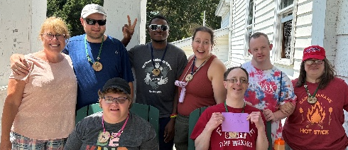
For Ages 18-50
This week is for mobile and self-sufficient individuals with moderate developmental disabilities who must have the stamina to do a +1 mile hike and provide self-care. The week includes swims, cookouts, crafts, and daily Bible time. Campers live in an air-conditioned Retreat Center, which is their home-base for the week. We will also rock climb, canoe, and ride on the Wanake wagon.

June 22-26 (Monday-Friday)

$685 – Tier 1 - $660 Early Bird (register by April 15); $635 SUPER Early Bird (register by March 15)
$757 – Tier 2 - $732 Early Bird (register by April 15); $707 SUPER Early Bird (register by March 15)
$872 – Tier 3 - $847 Early Bird (register by April 15); $822 SUPER Early Bird (register by March 15)

Wanake
Aldersgate
Asbury
Wanake is located at
9463 Manchester Ave SW, Beach City, OH 44608

Wanake’s sister camps also welcome you.
Aldersgate (in Carrollton, Ohio)
Asbury (in Hiram, Ohio)
Why Camp?
Now more than ever, our children need the opportunity to

- be outside in God’s creation,
- be adventurous,
- build a relationship with God,
- connect with each other in safe ways,
- be mentored by positive Christian role models,
- and have fun!

Wanake offers your family a safe, fun place to explore God’s creation and build relationships with God, others, and ourselves.
Clean, comfortable facilities on Wanake’s 250 acres are staffed by capable, mature, caring counselors who love Jesus, children, and the out-of-doors. Deep understandings are built, and new skills developed as campers and counselors live, laugh, study, create, work, and play in a Jesus-Centered environment in the out-of-doors. Counselors serve as mentors and role models as campers learn to live in community, building strong friendships and leadership skills.
I look forward to welcoming your family’s campers for an adventure that impacts lives for a lifetime and beyond!
Peace, Joy and Hope in Jesus, Julie Lautt, Director

Housing for Campers at Wanake
Cabins and Retreat Centers

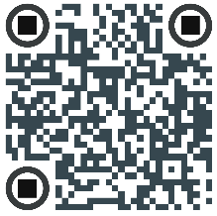
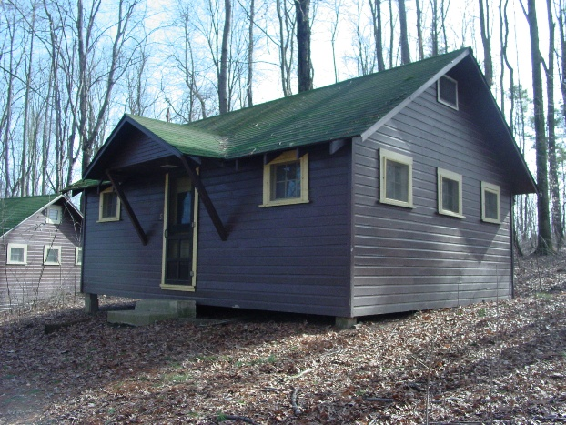
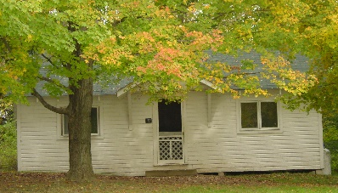
Cabins
Wanake’s traditional summer camp cabins feature bunkbeds, space for camper belongings, and a private changing area. The cabins offer the traditional camping experience with the modern conveniences of electricity and ventilation. Campers living in cabins walk to the nearby wash house or shower house for sinks, toilets, and showers. Three of the cabins are air conditioned, a good choice for campers with asthma.

View more pictures of facilities on
Wanake’s website.

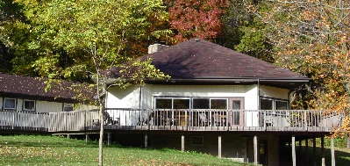
Retreat Centers
The retreat centers feature air-conditioning, restrooms and showers down the hall, and bunk beds in comfortable, carpeted bedrooms. An excellent choice for campers with asthma.

More Housing for Campers at Wanake
Rustic Locations
The Rock Lodge, The Survival Cabin, and The Adirondacks

The Rock Lodge
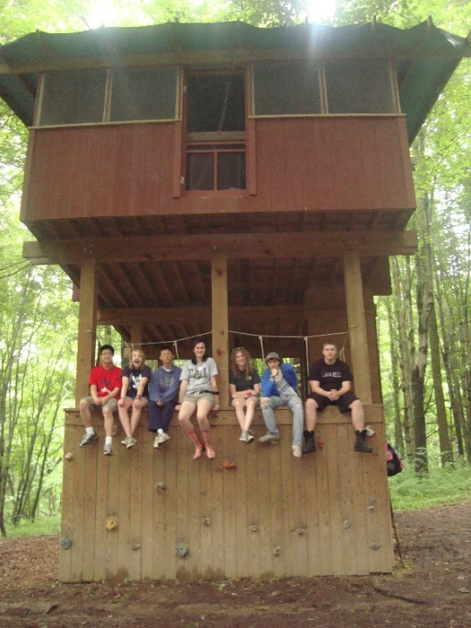
The Rock Lodge features a bouldering wall that campers climb up into the structure from ground level. (Bouldering is rock climbing horizontally rather than vertically). The second floor is a picnic shelter, which makes for a great place to do activities, out of the sun/rain. Campers climb into their bedrooms up a built–in ladder through a trap door. Hammock style beds hang from the ceiling of the structure as campers enjoy sleeping in the treetops. The top floor is completely enclosed for safety and security. Enjoy the rustic atmosphere while sleeping in the stratosphere 30 feet off the ground. There is fresh drinkable water on site, no electricity, and the nearest bathroom is a commercial portable toilet around the corner from the living space. Campers shower in the main camp. The Rock Lodge is sure to be one of the coolest places you have ever slept.

Survival Cabin
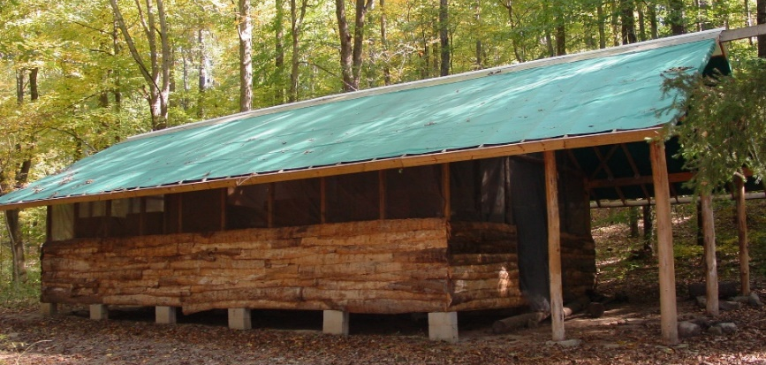
As the legend goes...a plane crash landed in the back woods of Wanake. No one was hurt. The passengers got out, and before night fell, they constructed a shelter- the Survival Cabin. They had a great night’s sleep, woke up the next morning to the sound of campers hiking over the hill, and were saved. In gratitude, they gifted Wanake their cabin & plane. Of course, this is a legend! This completely enclosed cabin has a canvas roof and the rustic feel of a cabin constructed by crash survivors. The Survival Cabin offers an authentic survivalist experience with no electricity in a secluded environment.
It is located near the composting toilet. Campers shower in the main camp.

Adirondack Shelters
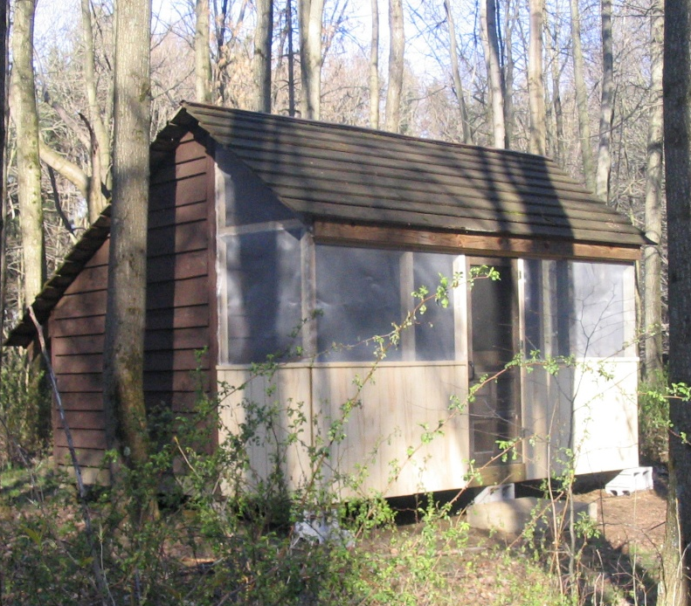
Experience camp life in Wanake’s Adirondack Shelters—a unique and rustic setup inspired by the classic shelters of the Appalachian Trail! These three-sided cabins have a screened-in front, keeping you close to nature while staying mosquito-free. Live simply—there’s no electricity, but plenty of fresh air, laughter, and late-night conversations. The smaller shelter sleeps 6, and the larger shelter sleeps 10, making it perfect for friends to share an unforgettable adventure.
Stay in a shaded area near the Woods Shelter, a favorite spot for hanging out, playing games, or staying dry when it rains. The composting toilet is close by and campers shower in the main camp.

Visit Wanake to meet leadership, see facilities and try out the fun!
Come to the Resurrection Egg Hunt and Camp Preview Day,
Saturday, April 25, 2026, 2-6 PM



Visit the Wanake Website to see photos of the site and facilities and learn more about Wanake’s summer camp program and year-round ministry.

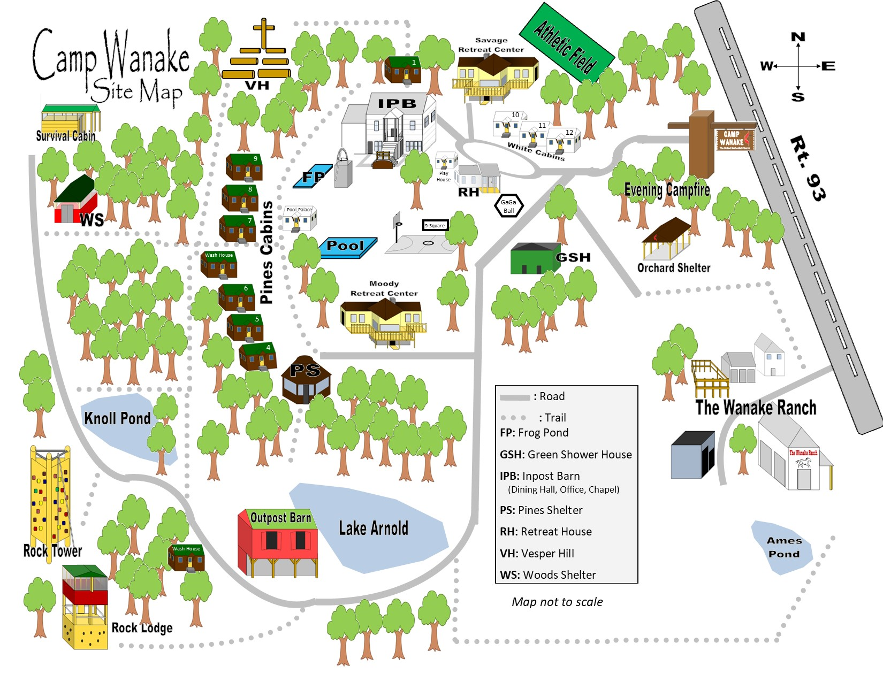
Important Information about Wanake Summer Camp
Who Will Care for My Camper?
Staff members, paid and volunteer, are carefully screened, selected, trained, and supervised by a year-round staff with 50+ combined years of camp experience. The staff is comprised of adults of all ages, including college students & high school graduates.

How does spiritual formation and Bible study work at camp?
Wanake’s study of the Bible revolves around an experience-based interaction with the Word of God, worship, prayer, and a community based on God’s unconditional love. In exploring God’s Word, campers will be challenged to learn how to pray for themselves and others, see the work of the spirit in themselves and others, participate in small group worship, and be an agent of God’s unconditional love. Wanake’s goal is that each camper builds a relationship with God as they experience a community of unconditional love that points to God.

How is health care handled at Wanake?
Health care is provided through the health director who lives on site and a Registered Nurse who visits daily. All staff members have training in their healthcare responsibilities and follow the Camp Doctor’s standing orders for minor illness & injury, including first aid and over-the-counter medications.
All medications are kept locked in the Health Center or a medical lock box and are monitored by staff. The Health Director monitors campers to make sure medications are taken as prescribed and that healthcare needs are met.

Get all the details on the website!

Contact Wanake’s leadership team by:
Email: amy@campwanake.org
Phone: 330-756-2333
Medical, Behavioral, Dietary, and Social/Emotional Needs
Wanake’s goal is to provide an excellent experience for each and every camper. We are best able to meet this goal when we are able to plan in advance and partner with parents. Please follow the following steps:
Before registering - Call Wanake.
Wanake is able to accommodate special medical, behavioral, dietary, and social/emotional needs for which the camper is able to provide some self-care and self-regulation with a pre-arranged plan. For summer 2026, Wanake may be able to provide one-on-one buddies for campers with special needs. Please contact Wanake before enrolling to review your camper’s needs at 330-756-2333 or info@campwanake.org.
After Registering
#1 Notify Wanake
Once you have registered your camper, notify Wanake. This will give Wanake staff and your family time to plan and prepare together for an excellent experience.
#2 Medication and/or Behavioral Plans
If a camper is on medication or follows a behavioral plan during the school year, Wanake recommends that the camper continue the same medication or behavioral routine while at camp. Part of the fun of camp is adapting to a new environment and a new daily routine. Since campers’ experience so many changes it is generally not a good idea to alter normal medication or behavioral routines during a stay at camp. Wanake asks that campers on psychotropic medication who have had a change in medication or dosage within three months prior to their arrival at camp notify Wanake.

What will my child eat at Wanake?
The Wanake Kitchen serves healthy, kid-friendly food and provides opportunities for campers to exercise decision-making in their food choices.
Wanake serves a variety of fresh fruits and vegetables – yogurt, granola, and fresh fruit with hot entrees at breakfast, salad with lunch, and fresh fruits and vegetables at supper and on cookouts. Many foods are cooked from scratch and desserts are baked homemade, reducing the use of high fructose corn syrup, artificial sweeteners, artificial colors/dyes, and hydrogenated oils. Finally, Wanake provides plenty of food for active campers engaged in energetic camp activities. With a pre-arranged plan Wanake can provide a balanced diet for those with food allergies and/or special diets: gluten-free, vegetarian/vegan, lactose intolerant, etc.
Please contact Wanake before and after enrollment to review your camper’s dietary needs at 330-756-2333 or amy@campwanake.org.

Tiered Pricing
East Ohio Camps understands that families have different abilities to pay for a Christian camping experience. Tiered pricing allows you to choose the rate that best fits your financial situation. The pricing option you choose remains confidential and in no way influences the experience your camper receives.
- Tier 1 is the rate we are able to offer thanks to the contributions of the East Ohio Conference of the United Methodist Church and other generous donors.
- Tiers 2 & 3 reflect your generosity in covering the true costs of operating the summer camp and securing the future of the camping ministry in East Ohio.
Want to know more about Tiered Pricing? Go to www.EOCSummercamps.org for more information.

Is the Cost of Camp Stretching Your Budget?

Please remember that in addition to these rates, additional financial assistance is available to ensure that all children have the opportunity to attend camp.
- You can pay in multiple payments. Call the East Ohio Camps office at 800-831-3972 ext. 139 to arrange a payment plan that works for your family.
- Take advantage of the sibling discount if more than one child from your family is attending camp. Contact the camp office at 1-800-831-3972 ext. 139 or camp@eocumc.com.
- East Ohio Camps has campership funds available. Go to the Wanake website to apply for a campership – www.campwanake.org. You may also contact Gary Jones at 1-800-831-3972 ext. 120 for an application.
- Your church may be able to help pay part of the cost. Check with your camp contact person or your pastor for details.

We hope you register soon.
We welcome your registration at any time this summer.

Upcoming Events at Wanake

For Families, Adults and Youth

Summer Camp 2026 Registration Begins!.....................December 26, 2025
Women’s Bible Study Weekend.....................................February 13-15, 2026

Wanake’s Annual Confirmation Retreat.........................February 20-22, 2026
Clergy Spouse’s Retreat..................................................March 6-8, 2026
Spring & Fall Workdays*...............................................Schedule a Date Today! *
Spring Workdays............................................................Saturdays in April and May - TBA
Men’s Walk to Emmaus Weekend.................................April 9-12, 2026

Women’s Walk to Emmaus Weekend............................April 16-19, 2026
Resurrection Egg Hunt and Camp Preview Day............April 25, 2026
Alumni Work Week & Weekend...................................April 28- May 3, 2026
Wanake Alumni Annual Ingathering.............................May 1, 2026
Dave Kennat Memorial Workday..................................May 2, 2026
Memorial Day Family Weekend Camp-O-Rama ..........May 22-25, 2026

One Day Adventure.......................................................June 2026
Summer Camp...............................................................June 14- July 31, 2026
Parent Child Overnight..................................................August 8-9, 2026
Labor Day Family Weekend..........................................September 4-7, 2026
Wanake’s 80th Anniversary Celebration........................Fall 2026
Spiritfire Women’s Retreat............................................September 18-20, 2026


Check the Wanake Website Event Page for details.
Contact Wanake at 330-746-2333
or amy@campwanake.org.
